KX-AC60 fully automatic hollow coil winding Machine
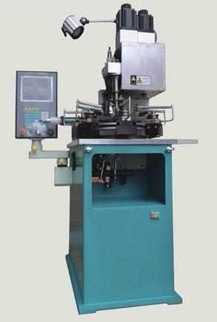

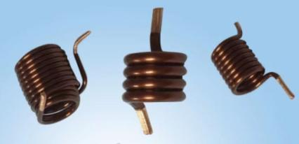

MACHINE INTRODUCTION：

The KX-AC60 model adopts the latest manufacturing process, which is morestable in winding, disconnect, and the phenomenon of running positions hasdecreased significantly. Optimize the design of mechanical structure, improve theoverall performance of the mechanical, and further reduce the repeated positioning error. Using a high -resolution servo motor, the twisting angle is more accurate. Themain axis uses German technology to develop and produce, and the beating errorhas been further reduced to meet the high internal diameter requirements of variousempty core coils. Products are widely used in various industries such as high -frequency, new energy, network transformers.

Main features:

- Use PC control, servo power, convenient mechanical adjustment, many exercisestations, and can inject hollow coils of various shapes.
- The upper control system adopts the international top CNC controller, high -performance dual -core CPU, Windows operation interface, 10 -inch LCD touchdisplay, the screen is clear and intuitive, stable, easy to learn, easy to understand,easy to operate.
3. The power system is an imported high -precision servo motor, which is organicallymatched with the CNC control system, which has accurate synchronization, reliablecontrol, accurate motion position, and can make high -required various empty corecoil products. Essence4. Choose a hollow coil semi -automatic peeling machine, which can achieve large -scale round line peeling and thinning

Wire diameter: | 0.8 ~ 4.5mm (according to reality)
Twist handle length: | ≤45*50
The biggest work itinerary of the line shaft: | 80
Roll line direction: | positive, reverse around
The minimum instruction value of the roll axis: | 0.1̊
The maximum instruction value of the roller shaft: | ± 99± 359.9
The minimum setting value of the camshaft: | 0.1
Maximum setting value of the  camshaft: | 359.9
Minimum setting value of the lifting shaft: | 0.01
The maximum setting value of the lifting shaft: | 100
Out of production per minute: | 5-6
minutes/minute (winding)  Send line servo: | NO
Rolling line servo: | 1.5kW
Clear servo: | 3.0kW
Lift servo: | 1.5kW
Total power: | 6.0kW
Machine size: | 3200*1300*1900
Machine weight: | 950kg
The main technical parameters

Packaging
Packaging Material: Carton/Wooden case with foam inside.

- General package(Paper carton or plastic bag): For small equipped parts for Digital CNC Wire Coil Winding Machine, Package it with form and pack paper to guarantee unbroken during the transport.

- Wooden case package: For larger scale Digital CNC Wire Coil Winding Machine ,we have special skilled carpenter, who would make the proper wooden case with exact thickness, density,length. The up arrow ↑marked on the outer wooden case. Buffer material would be put in the wooden case to prevent crack and shock.

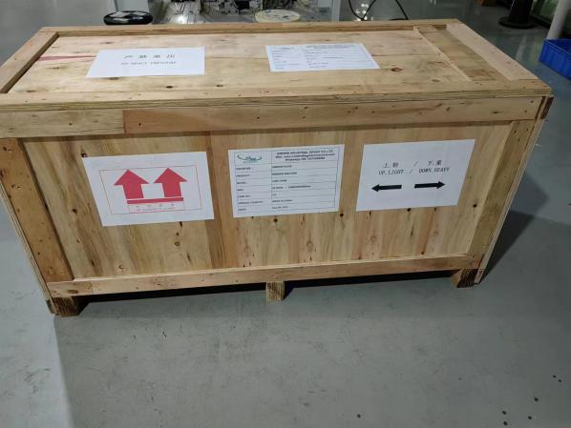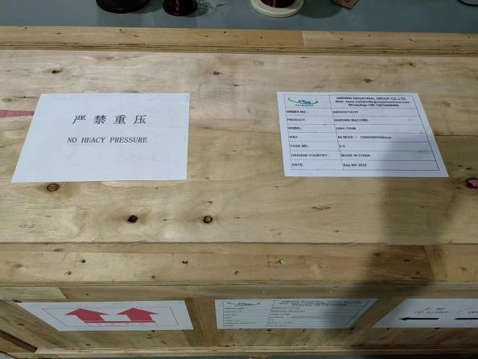

FACTORY:
We, KIOXIA LIGHT RING EQUIPMENT GROUP CO.,LTD. have been experts in winding machine lines for 28 years, with our advanced product portfolio featuring innovative solutions like the KX-AC60 fully automatic hollow coil winding Machine—a state-of-the-art automated system engineered for precise, efficient winding of hollow coils, embodying our technical expertise in specialized coil manufacturing technology.

Our KIOXIA brand holds authoritative certifications and recognitions, including ISO9001:2015, CE approvals, multiple machine patents (encompassing key innovations in models like the KX-AC60 fully automatic hollow coil winding Machine), and the official designation of "high-tech enterprise" by the government. These credentials fully validate the reliability, precision, and technical excellence of our entire product range, reinforcing our commitment to delivering professional winding solutions for diverse coil manufacturing needs.
