NAME：KXP80 Fully Automatic hollow winding machine

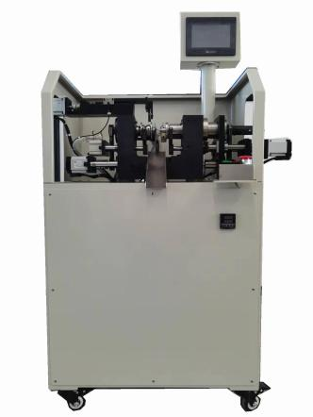

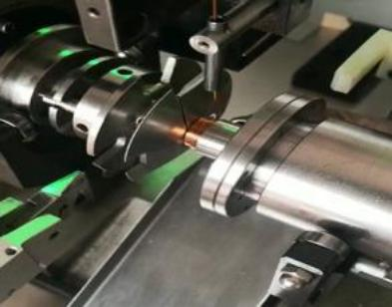

SPECIFICATION:
Coil maximum processing size: | Outer diameter: 70mm, width: 20mm
Maximum spindle speed: | 5500rpm
AC servo motor: | Main Spindle :400W X axis :400W Y axis :400W
Axis rotation Angle: | 360 。 a circle , set unit 0 . 1 。
Shaft stop accuracy: | plus or minus 0 . 1 。
Wire diameter: | 0 . 03 - 0 . 8mm
Equipment curing heating temperature: | 30 - 500。
Axis movement: | X:60mm Y :60mm
Shaft moving guide pin  transfer speed: | 350mm/sec
Control mode: | CNC 5-axis control board (independently developed)
Storage: | RAM+FLASH storage, no data loss failure
Power supply voltage: | single-phase three-wire system
Power supply voltage: | 220V,50HZ
Power consumption: | 1.5KW
Compressed air pressure: | 0.5-0.8MPa
Equipment size: | 800mm (L) *600mm (W) * 1410mm (H)
Weight: | 150Kg

MACHINE FEATURES ：
1. Key components of machines are imported from Taiwan or Japan, with strong reliability, high durability, and greatly increased the service life of the equipment;
2. The design is novel, the structure is simple and reliable, and the operation is simple and convenient;
3. The equipment adopts independent research and development of CNC high -speed motion control board card, touch screen human machine dialogue and debug parameters, Chinese and English shows easy understanding;
4. The device has automatic hanging, automatic cutting, and automatic alarm and stopping function. Single people can watch more than 10 equipment;
5. Equipment standardization design from the expansion function of the plug -in module of the organization, with the secondary development function module;
6. The equipment line line has high accuracy and is suitable for various conventional and
exotic inductance coil winding in the wireless charging and electrical industry. It has the high -torque and high -precision servo wide -shaped demolition function (replaced by traditional cylinder release);

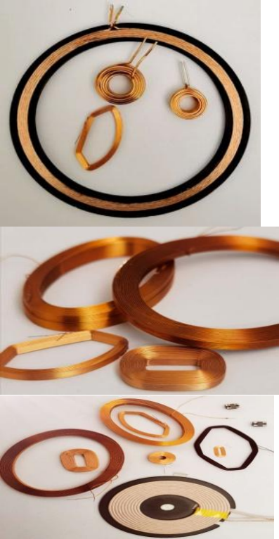

PRACTICAL APPLICATION :

Training for Customers on GWP80 Fully Automatic Hollow Winding Machine Operation
1.All service engineers with 10 years of experience have received special technical training, including specialized expertise in the GWP80 Fully Automatic Hollow Winding Machine, enabling them to effectively handle various breakdown issues specific to this automated hollow coil winding equipment.

2.We guide users to accurately operate and maintain the GWP80 Fully Automatic Hollow Winding Machine—with focused attention to its automated hollow coil winding mechanisms, precision controls, and coreless winding configurations—while providing free consultation about the production process technology of electronic products, particularly those involving hollow coil manufacturing.

3.To ensure the GWP80 Fully Automatic Hollow Winding Machine operates normally, we conduct dedicated training on its automated functions, operation procedures, usage, and maintenance through English manuals, model-specific instructional videos, and online guidance, tailored to the unique requirements of this fully automatic hollow winding equipment.
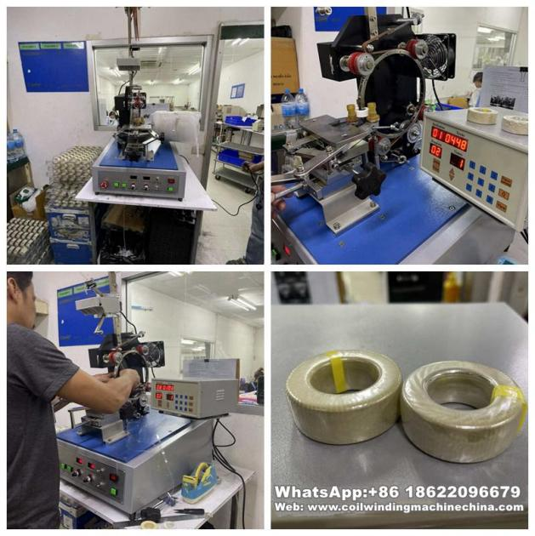

PACKAGING:

Packaging Material: Carton/Wooden case with foam inside.

1.General package(Paper carton or plastic bag): For small euipped parts for Hook Type Transformer Winding
Machine, Package it with form and pack paper to guarantee unbroken during the transport.
2.Wooden case package: For larger scale Hook Type Transformer Winding
Machine,we have special skilled carpenter, who would make the proper wooden case with exact thickness,density,length. The up arrow ↑marked on the outer wooden case. Buffer material would be put in the wooden cas e to prevent crack and shock.
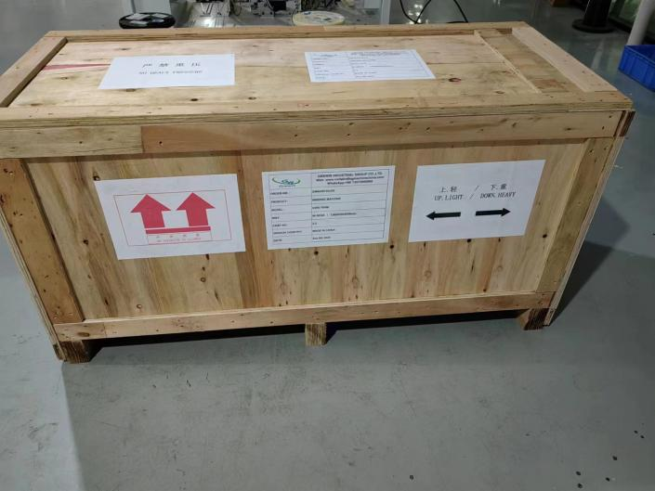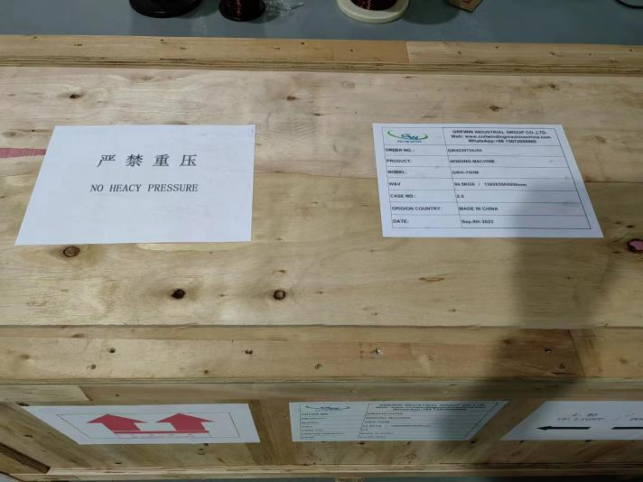

FACTORY:
We, KIOXIA LIGHT RING EQUIPMENT GROUP CO.,LTD. have been experts in winding machine lines for 28 years, with our innovative product range featuring advanced solutions like the GWP80 Fully Automatic Hollow Winding Machine—a cutting-edge automated system engineered for high-precision, efficient winding of hollow coils, embodying our technical prowess in specialized hollow coil manufacturing technology.
Our KIOXIA brand holds authoritative certifications and recognitions, including ISO9001:2015, CE approvals, multiple machine patents (encompassing key innovations in models like the GWP80 Fully Automatic Hollow Winding Machine), and the official designation of "high-tech enterprise" by the government. These credentials fully validate the reliability, precision, and technical excellence of our entire product portfolio, reinforcing our commitment to delivering professional winding solutions for diverse hollow coil and related component manufacturing needs.
